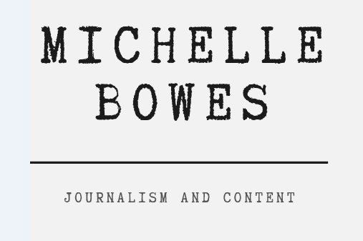

NEW CLIENT BRIEFING FORM
Please provide as much detail as possible

Type of communication and topic
Eg. Series of blog articles, whitepaper, social media posts
Frequency
Eg. One-off, monthly, quarterly, annually
Target audience
Eg. Existing clients, new customers
Aim of communication
Eg. Generate prospects, demonstrate expertise, convert prospects to customers

Distribution plan
Eg. Post on website, social media, distribute via newsletter
Length
Eg. Number of words or pages
Deadline
Eg. When work is due, or final publication date
Budget
Eg. For entire project, or writing component

Please email to michelle@michellebowes.com.au.
By returning this form you agree to be subscribed to our mailing list. You can unsubscribe at any time.

Upon receipt, I’ll review the details of your project and contact you with a quote within 48 hours.

